**Curve Fitting**

### Qinlu (Claire) Wang

### BCBB/OCICB/NIAID

**Outline**

1. How to perform curve fitting?
2. Comparing models/curves
3. How to customize equation of models?
4. **How to perform curve fitting**
5. Simple Linear Regression

Let’s take simple linear regression with curve fitting as an example. Linear regression fits a straight line through your data to find the best-fit value of the slope and intercept.

Choose the **sample data** with XY data table: **Simple Linear Regression**

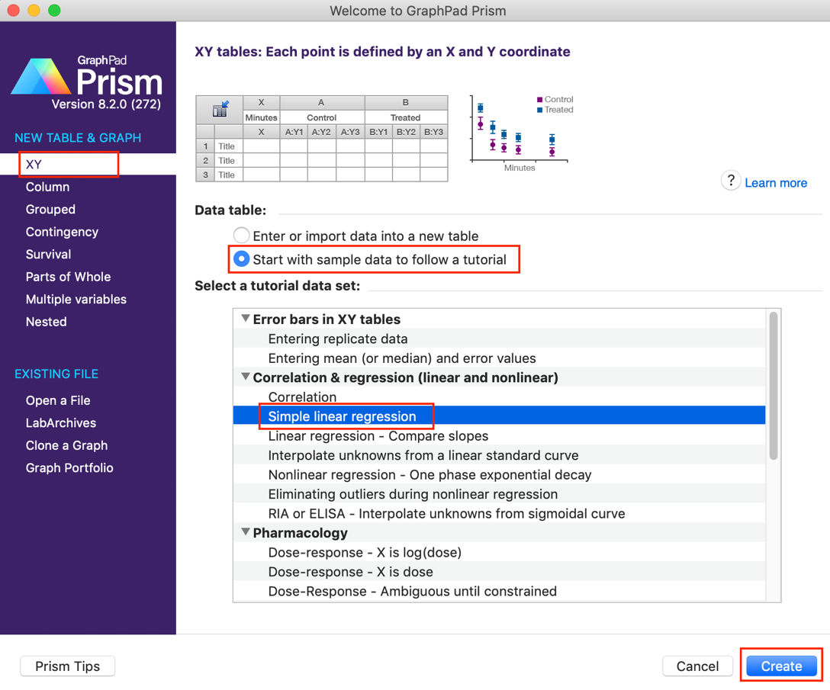

In this example, the X values are the percentage of a certain kind of fatty acid in muscle (from a biopsy) and the Y values are insulin sensitivity.

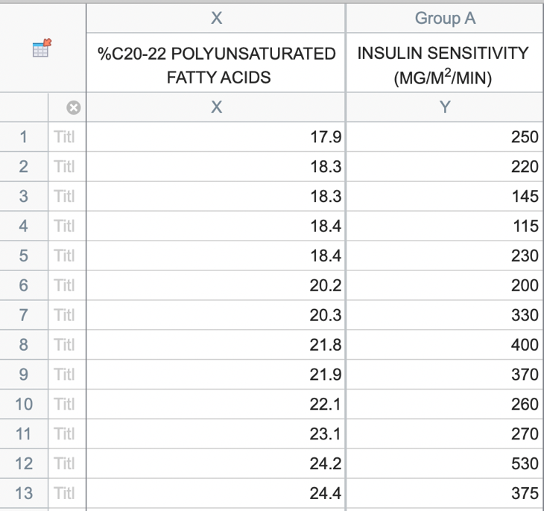

The corresponding graph is like:

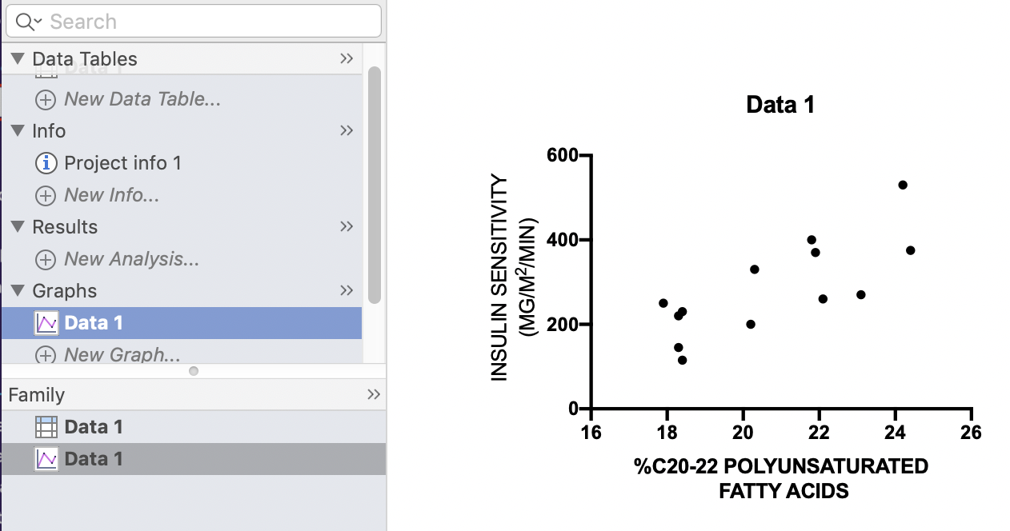

**Click “Analyze”**. In the Analyze Data dialog, **select “Linear regression”** under the “XY analyses”. Then **click “OK”**.



In the “Parameters: Linear Regression” dialog, check the **“Show the 95% confidence bands of the best-fit line”** then **click “OK”**.

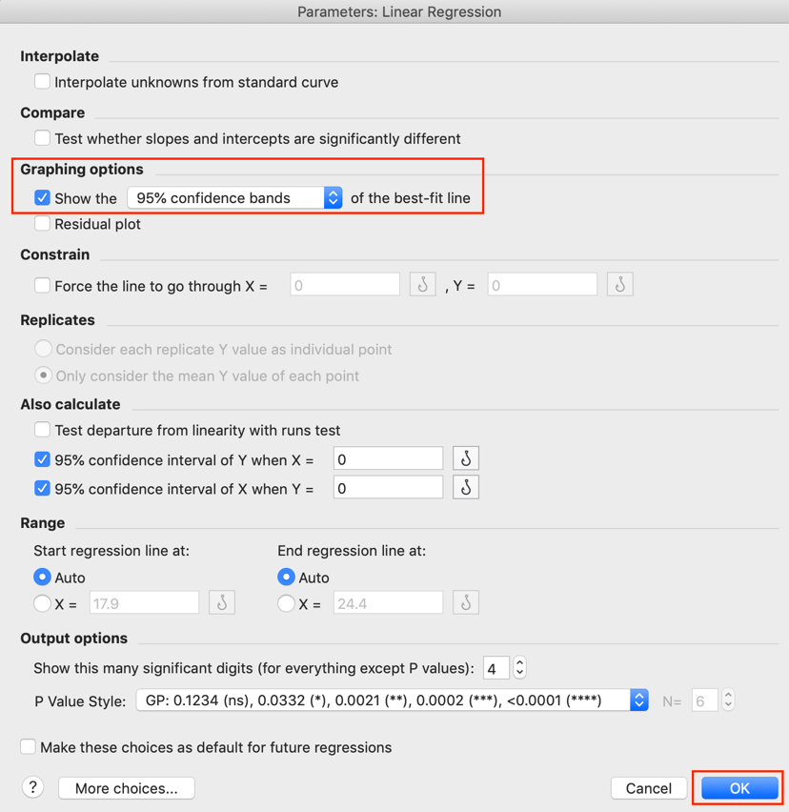

Then Prism presents a full set of linear regression results.

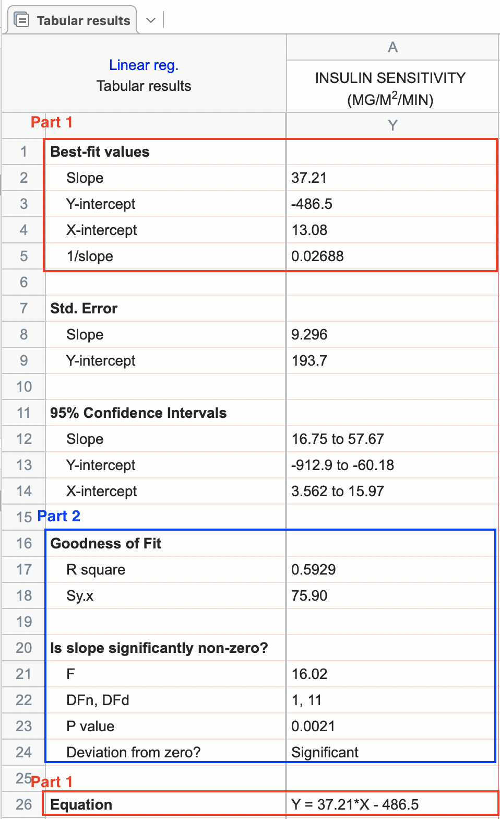

Results Explanation:

1. Part 1: Slope and Intercept

Prism first reports the best-fit values of the slope and intercept. It also reports the X intercept and the reciprocal of the slope.

At the bottom of the results page, the slope and intercept are reported again in the form of the equation that defines the best-fit line. You can copy this equation and paste onto a graph, or into a manuscript. In this case, the best-fit line is Y = 37.21*X – 486.5

1. Part 2: Goodness-of-fit of linear regression

Prism provides R-square for goodness-of-fit. You can think of R-square as the fraction of the total variance of Y that is “explained” by variation in X.

In the corresponding graph, two confidence bands surrounding the best-fit line define the confidence interval of the best-fit line. The dashed confidence bands are curved and they are the boundaries of all possible straight lines.

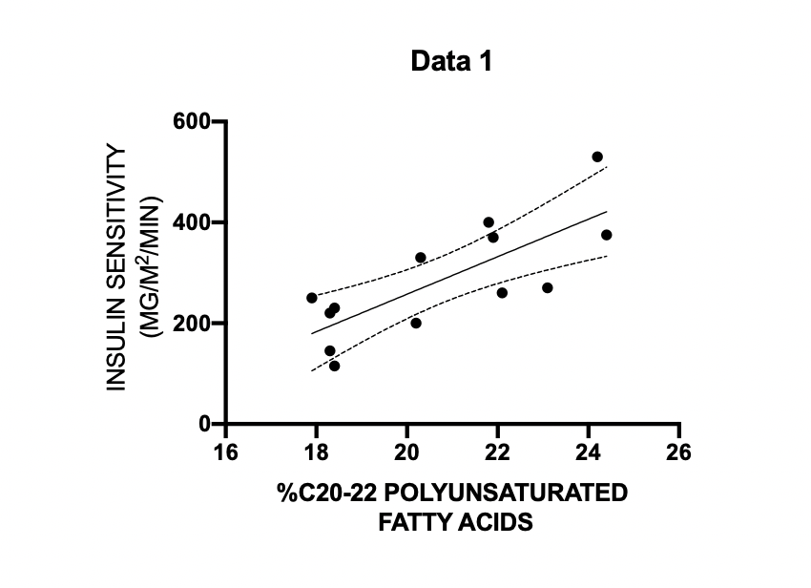

1. Nonlinear Regression: Dose-response – X is dose

Then let’s try a nonlinear regression example. Choose the **sample data** with XY data table: **Does-response – X is dose.**

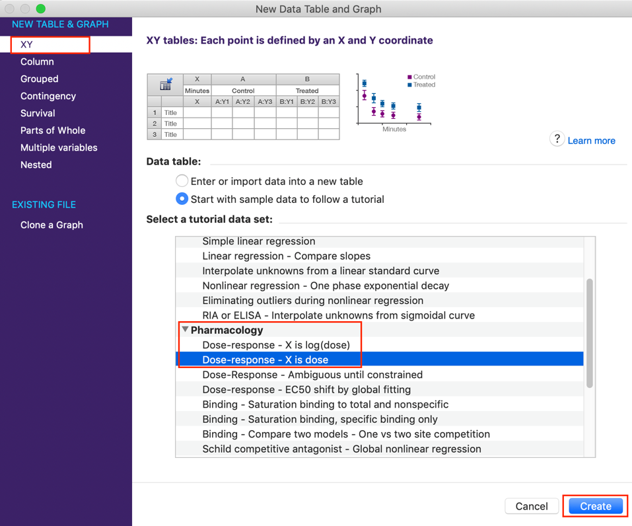

In this example, the X values are molar concentration. The Y values are responses (in triplicate) in two experimental conditions. We would like to fit a dose-response curve to determine the EC50 of the drug, and its Hill Slope, in both conditions.

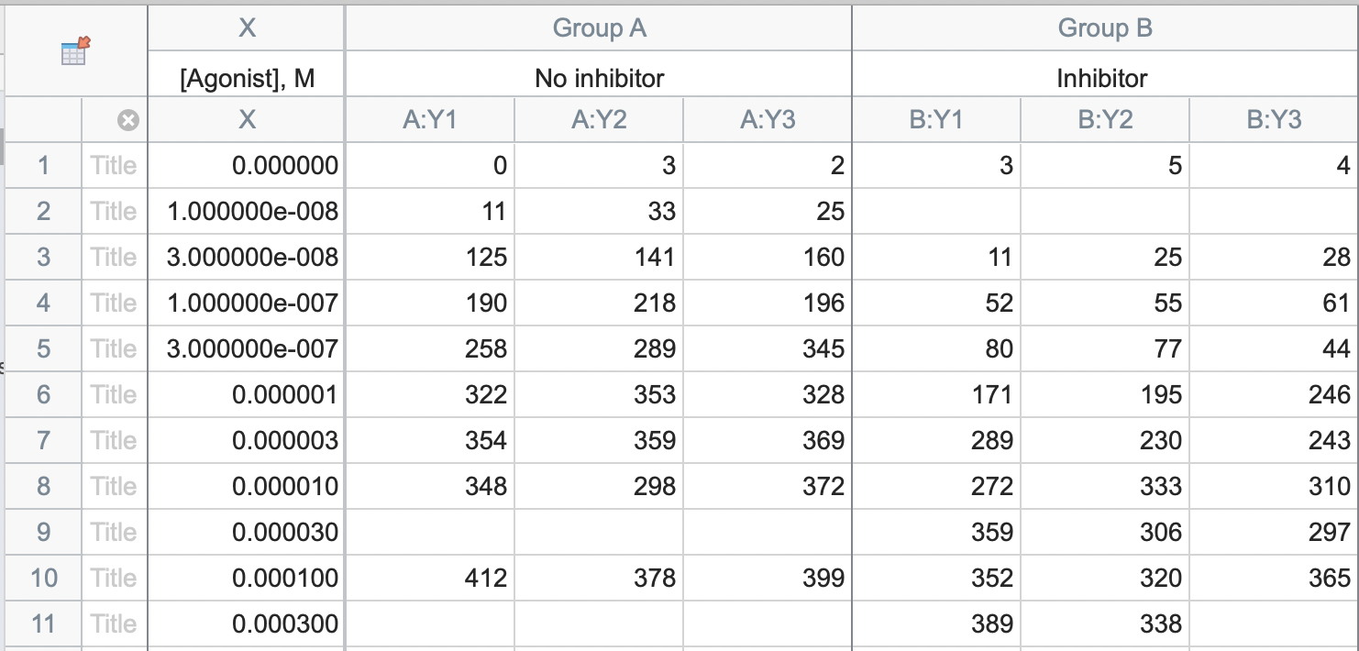

**Click Analyze**. Choose “**Nonlinear regression (curve fit)**” then **click “OK”**.

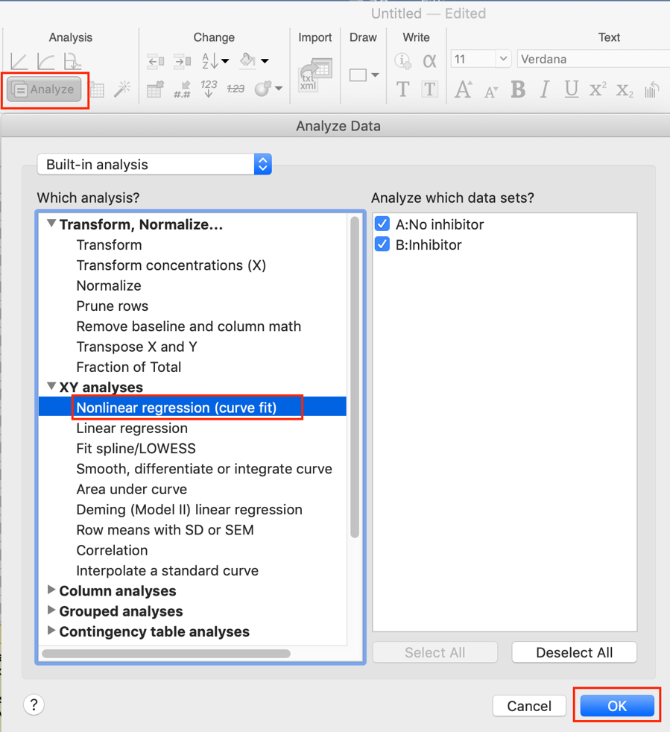

In the “Parameters: Nonlinear Regression” dialog, choose **“[Agonist] vs. response (three parameters)”**. **Click “OK”**.

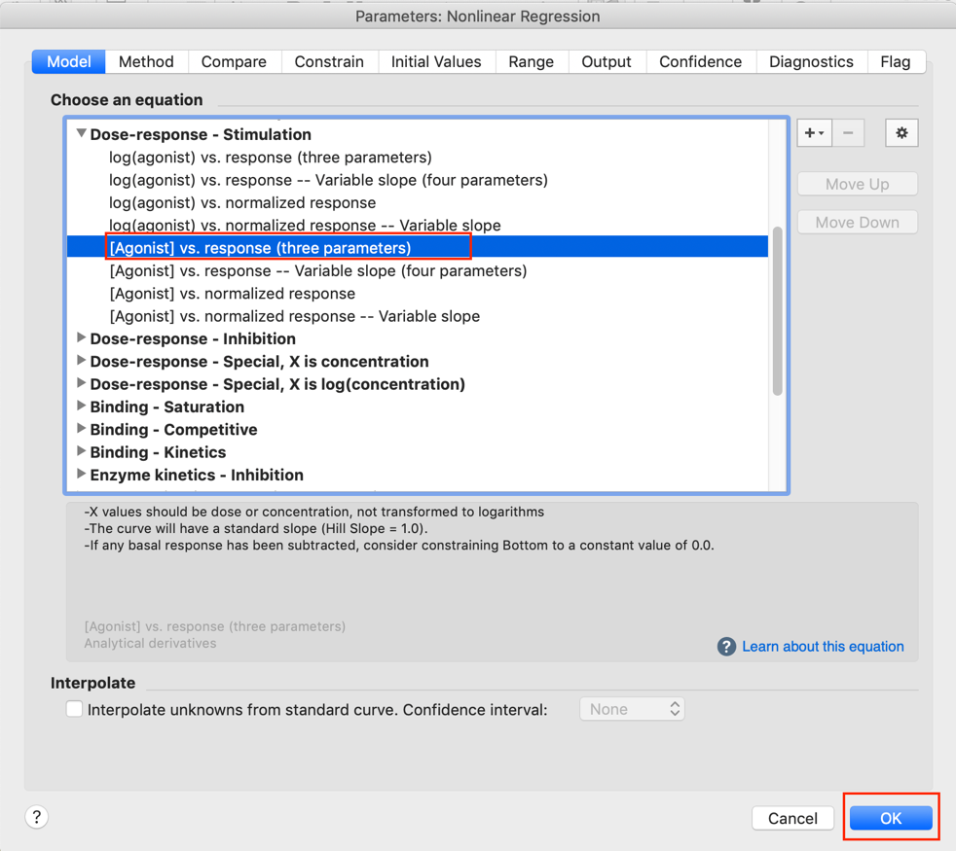

Then the results will be like:

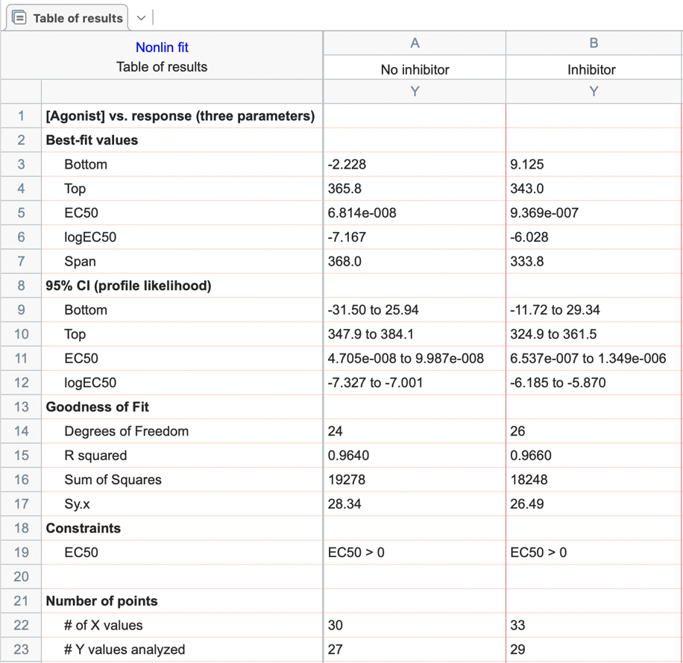

More detailed interpretation of these results could be found at: Interpreting results: Nonlinear regression.

1. **Comparing models**

Previously the dose-response model was generated WITHOUT a variable slope parameter. Now let’s compare it with another dose-response model WITH a variable slope parameter.

**Double click the header** of the previous results.

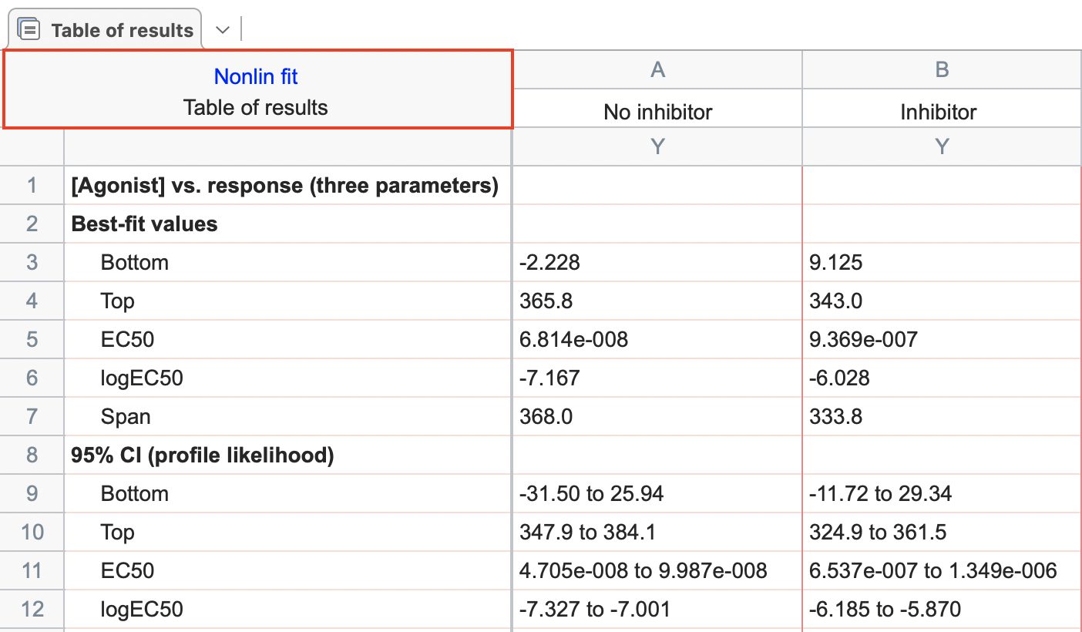

Go to the 3rd tab “**Compare**”. Choose “**For each data set, which of two equations (models) fits best?**” as the question we would like to answer; Choose “**Extra sum-of-squares F Test**” OR “**Akaike’s information Criterion (AICc)**”as the comparison method; Choose **“[Agonist] vs. response – Variable slop (four parameters)”** as the second equation. **Click “OK”.**

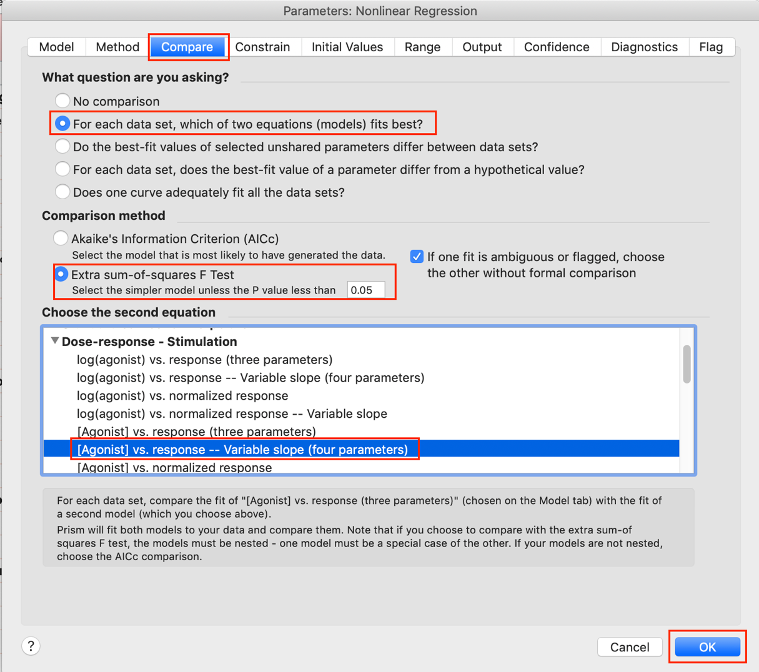

Prism offers two approaches to comparing models with different numbers of parameters: Extra sum-of squares F test and Information theory approach Akaike’s criterion (AIC):

1. Extra sum-of squares F test

The F test compares the difference in sum-of-squares with the difference you would expect by chance. If the p-value is small, conclude that the simple model is wrong, and accept the more complicated model.

The results of comparing these two models are generated accordingly:

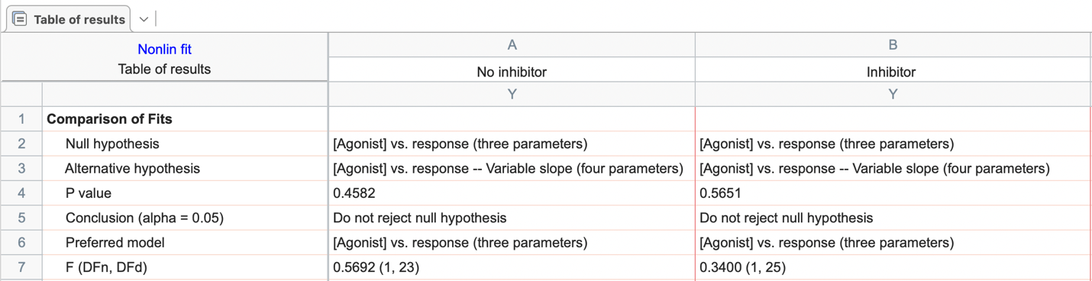

In this case, the p-values are ~0.5 which is larger than the traditional value of 0.05, we cannot reject our null hypothesis that the simpler model is correct.

1. Information theory approach Akaike’s criterion (AICc)

This alternative approach is based on information theory, and does not use the traditional “hypothesis testing” statistical paradigm. It determines how well the data supports each model, taking into account both the goodness-of-fit (sum-of-squares) and the number of parameters in the model. The results are expressed as the probability that each model is correct, with the probabilities summing to 100%. If one model is much more likely to be correct than the other (say, 1% vs. 99%), you will want to choose it. If the difference in likelihood is not very big (say, 40% vs. 60%), you will know that either model might be correct, so will want to collect more data.

The AICc results of this model comparison are:

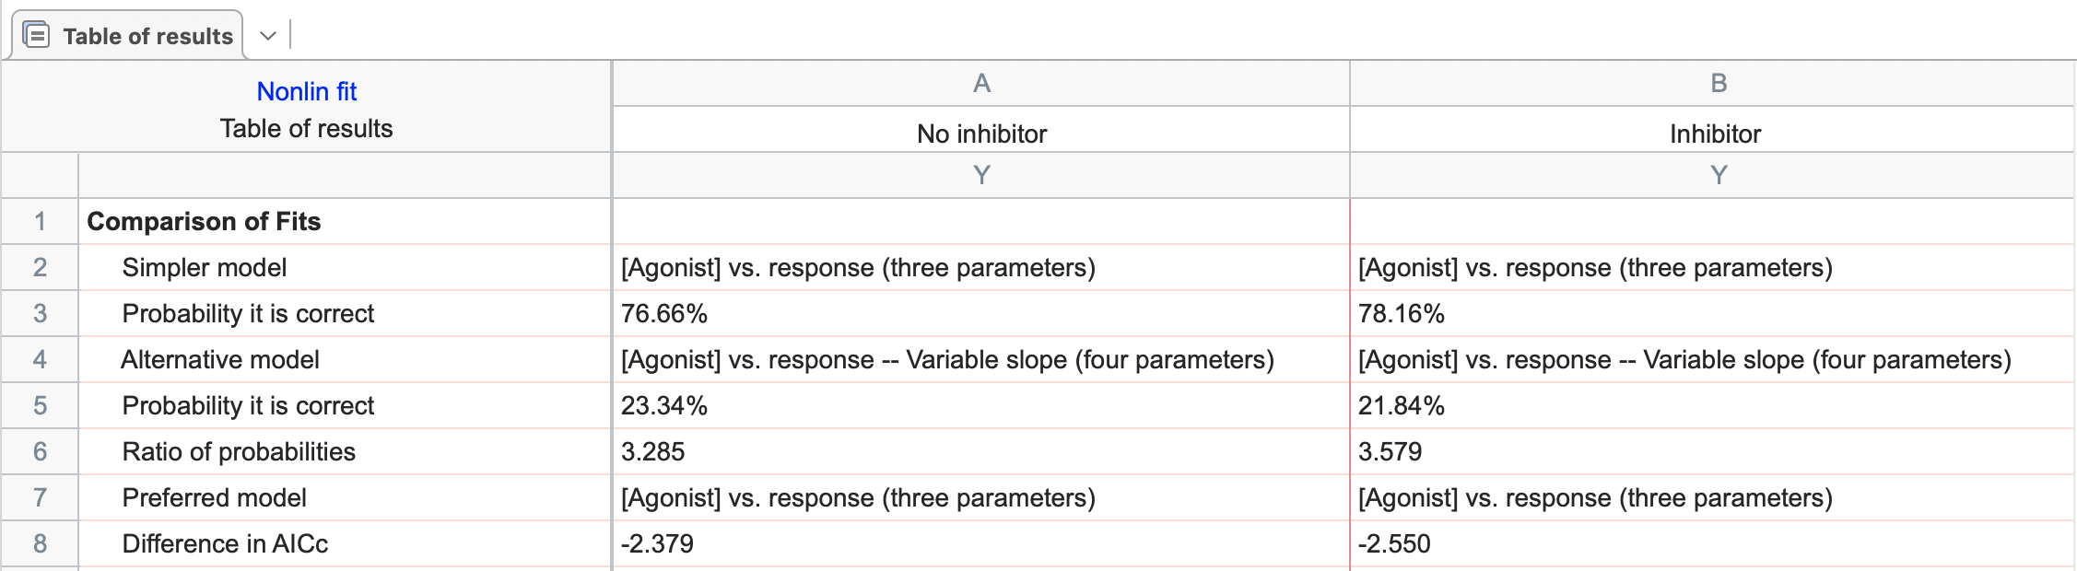

In this case, for the group “No inhibitor”, the probability that the model WITHOUT variable slope (76.66%) is correct is higher than the probability that the model WITH variable slope (23.34%) is correct. Therefore, the model WITHOUT variable slope is preferred.

Which approach to choose? F test or AICc?

* If the two models are nested (one model is a simpler case of the other), you may use either the F test or the AIC approach.
* If the models are not nested, then the F test is not valid, so you should choose the information theory approach.

1. **Customizing your equation of models**

Let’s take Boltzmann sigmoidal equation, a classical equation in Prism as an example. Import the **sample data** with XY data table: **Does-response – EC50 shift by global fitting.**

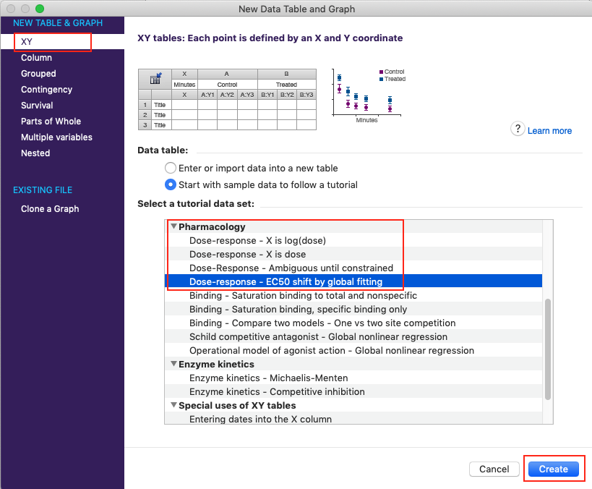

In this case, The X values are the logarithm of the concentration of agonist. The Y values are responses, in duplicate, in two conditions.

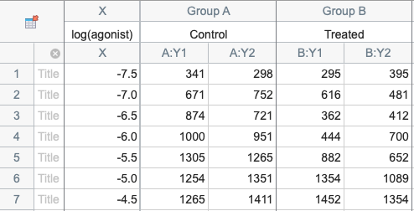

**Click “Analyze”**; Choose “**Boltzmann sigmoidal**” under the “Classic equations from prior versions of Prism”. Then **click the settings button** on the right.

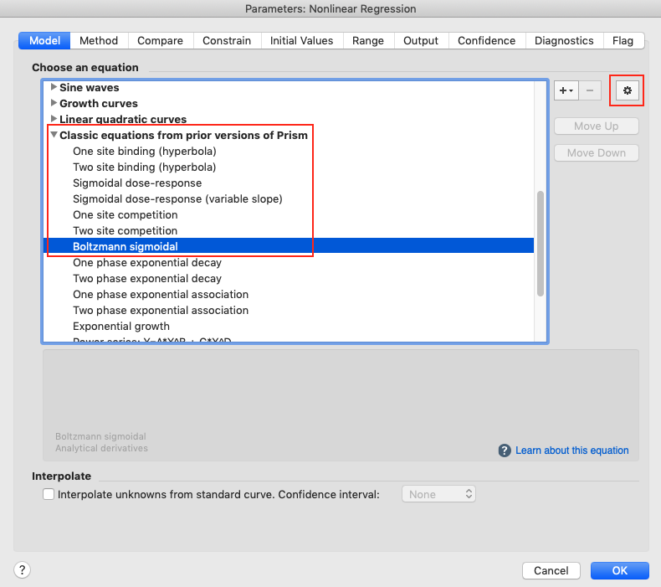

It shows a dialog which presents the Boltzmann sigmoidal equation as well as how this equation looks like in the graph on the right.

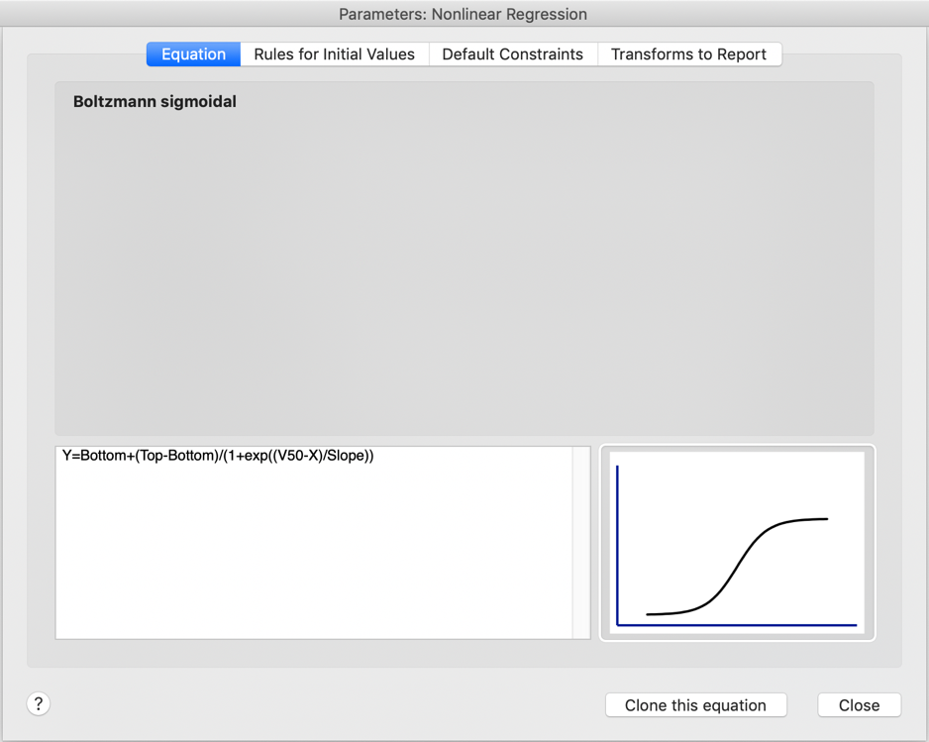

Click the tab “**Rules for Initial Values**” then you could see the initial values defined in the equation.

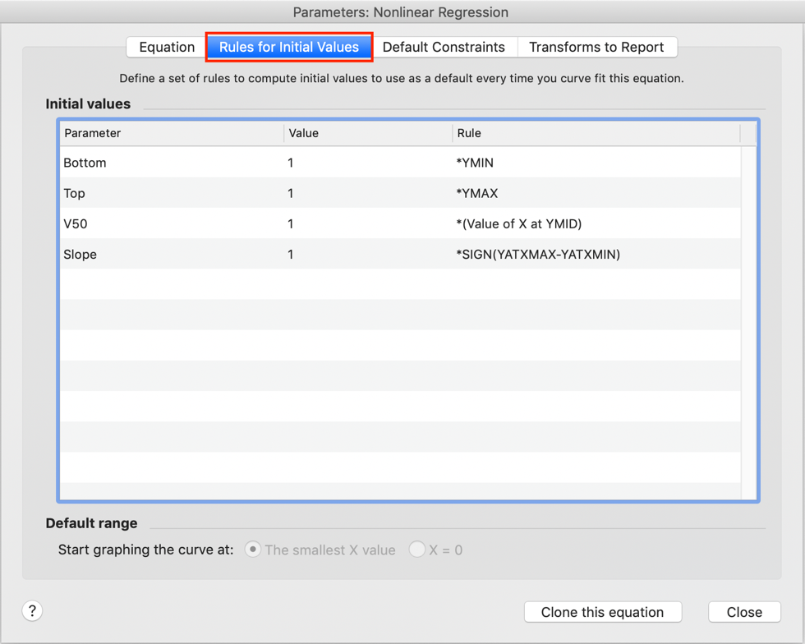

Why should we choose initial values? Nonlinear regression is an iterative procedure. The program must start with estimated initial values for each parameter. It then adjusts these initial values to improve the fit.

In this case, we define the initial Bottom as 1*Ymin, Top as 1*Ymax, V50 as 1*(Value of X at Ymid), and Slope as 1*SIGN(Y at Xmax – Y at Xmin).

These initial numbers of the equation could be customized by ourselves. Please **click the “Clone the equation”** on the bottom right. Then it pops up a new window for a new customized equation. You could name it and change the formula by your own.

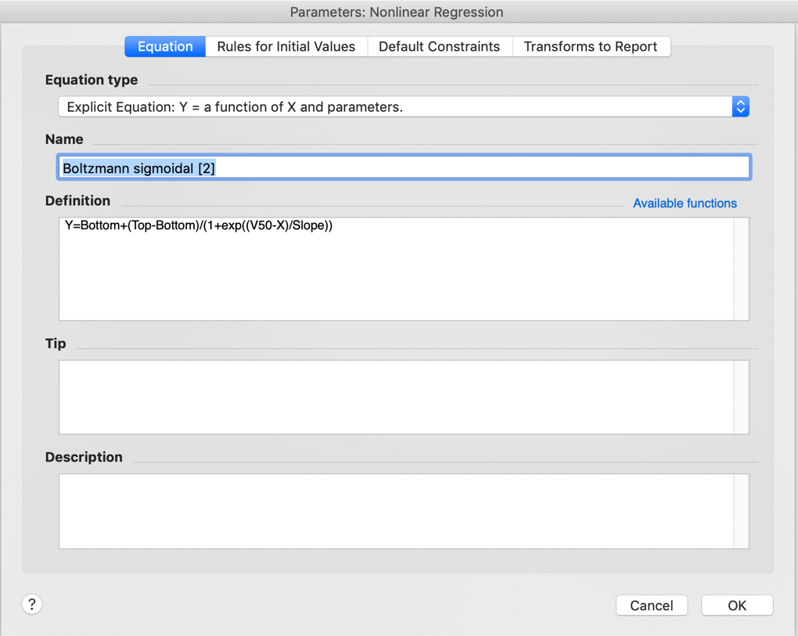

Then **click the tab “Rules for Initial Values”** on the top. You could customize the initial values for each parameter.

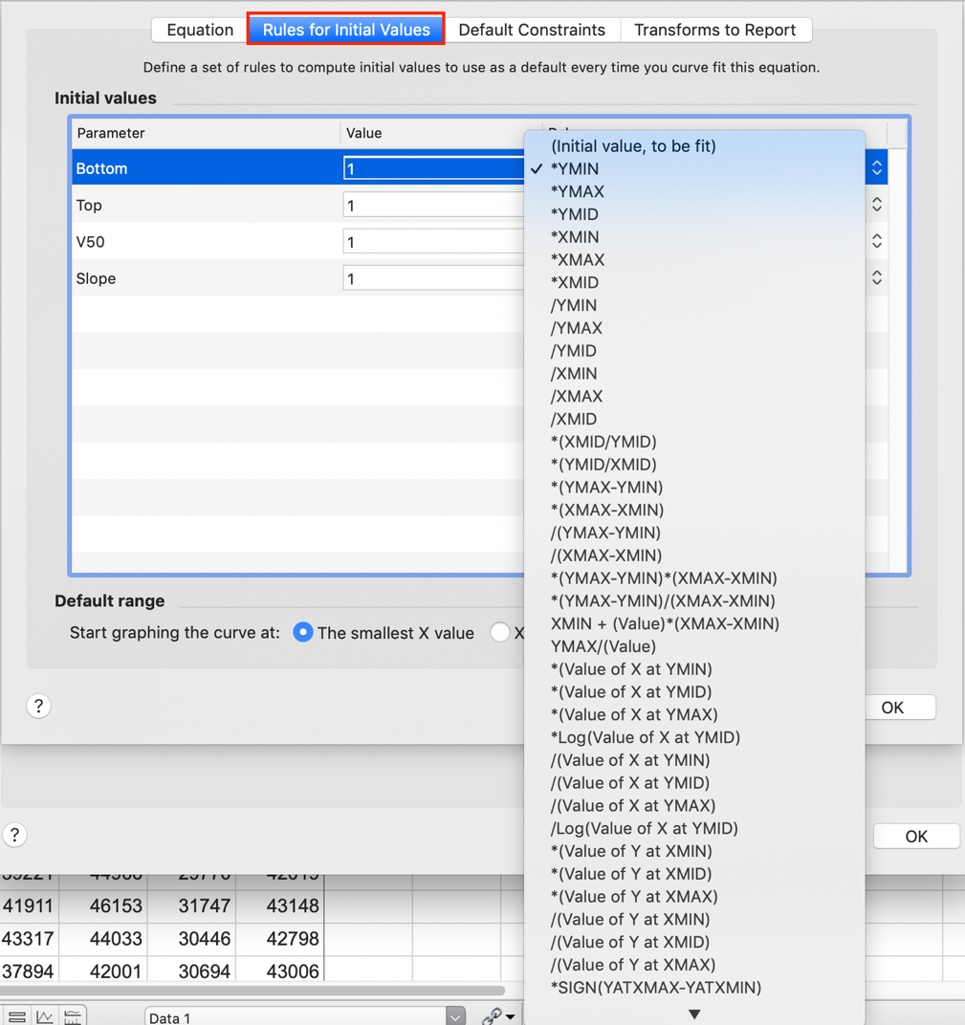

Once you **click “OK”**, Prism 8 generates a result table “Nonlin fit of EC50 shift”.

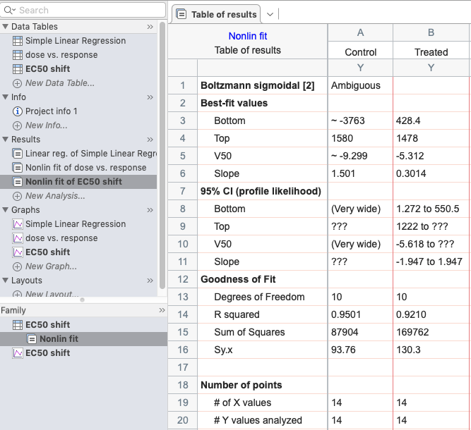

How to interpret the results?

* **Best-fit values:** the estimate of each parameter. Please note that these estimates are not necessarily equal to those initial values we defined in the equation.
* **95% CI:** Nonlinear regression is an iterative procedure. The program must start with estimated initial values for each parameter. It then adjusts these initial values to improve the fit.
* **Goodness of Fit:** 
  + R squared: quantifies goodness of fit. Higher values indicate that the model fits the data better.
  + Sum of Squares: This is useful if you want to compare Prism with another program, or compare two fits manually. Otherwise, the value is not very helpful.

**Conclusions**

1. BCBB keeps updating this file for more examples and explanations. Please feel free to watch/star our Github repository [BCBB Prism Lab: Curve Fitting](https://github.com/niaid/Prism/tree/master/Lab-7) to be notified for update.
2. If you have any further question, please let me know [qinlu.wang@nih.gov](mailto:qinlu.wang@nih.gov).

**Reference:**

[Prism 8 Curve Fitting guide](https://www.graphpad.com/guides/prism/8/curve-fitting/index.htm)